Image reolution

1. Radiometric resolution

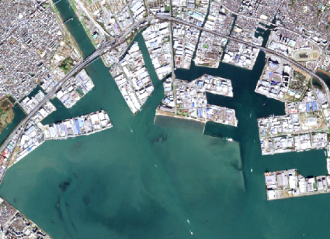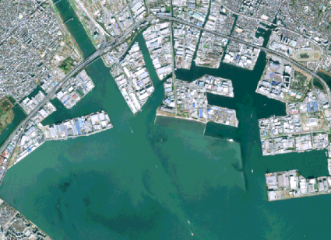

8 bit image 4 bit image

1. Smallest change in intensity(energy level) level that can be detected by the sensing system.
2. Limited by no of quantized level of ditize the continus intensity value
3. A 1-bit raster contains two values (zero and one). While a 8-bit raster ranges from 0-255 (256 values in total).
4. The 4-bit image has less variety in pixels like a classic Nintendo game. While the 8-bit image delivers more shades in each band with 256 in total.

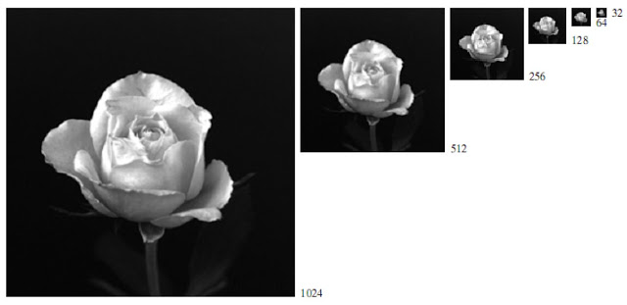

Spatial resolution dimention of image

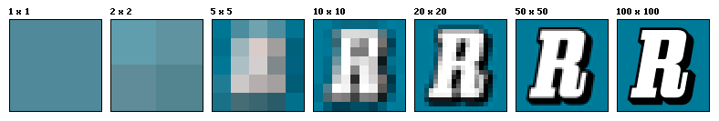

Pixel resolution dpi level of image

<https://apply.mpi-sws.org/accounts/password/reset/done/https://apply.mpi-sws.org/accounts/password/reset/done/>

<https://groups.oist.jp/grad/research-interns>

<http://global.ntu.edu.sg/GMP/ic/Pages/default.aspx>

<https://www.egr.msu.edu/undergraduate/resources/scholarships>

<http://int.technion.ac.il/academic-programs/summer-programs/summer-school-of-engineering-science/>

<http://ccb.jhu.edu/internship.shtml>

<https://itri.applytojob.com/>

<https://phd.pages.ist.ac.at/isternship/>

<https://www.sfp.caltech.edu/programs/surf/application_information>

<http://www.ia.nctu.edu.tw/ezfiles/0/1000/attach/5/pta_1817_3968209_14253.pdf>

<https://uwaterloo.ca/institute-for-quantum-computing/ura>

<http://careers.cern/students>

<http://www.inde.campusfrance.org/en/PAGe/charpak-research-internship-program>

<https://academicjobsonline.org/ajo/jobs/9845>

https://iusstf.org/program/for-indian-students

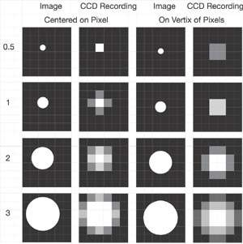spatial vs pixel resolution

**Infrared image fusion using NN**

**https://github.com/exceptionLi/imagefusion_deeplearning**

**https://github.com/exceptionLi/imagefusion_densefuse**